Reflection Fr A
Music: Y Y

Exit Hymn: Be Not Afraid

John Henry Newman's Prayer
May He support us all the day long,
till the shadows lengthen and the evening comes
and the busy world is hushed and the fever of life is over
and our work is done.
Then in His mercy may He give us safe lodging
and a holy rest and peace at the last.

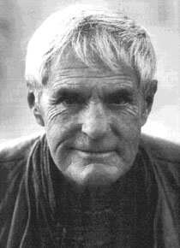

The X family deeply appreciates your presence here today, to join us
in saying our sad farewell to Michael, who will be always in our hearts.
PRAY FOR THE REPOSE OF THE SOUL OF
X_X
(1930 - 2017)

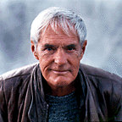

Eternal rest grant unto him, O Lord,
And let perpetual light shine upon him.
May he rest in peace.

